TREE

Height of a binary tree:-

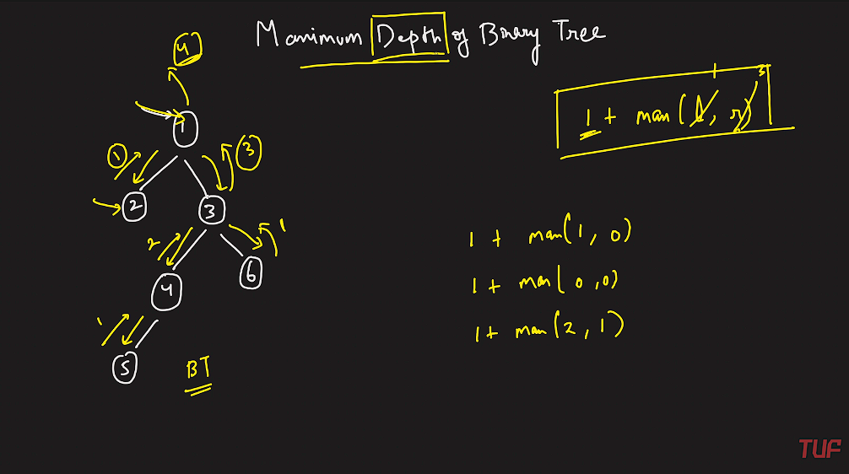

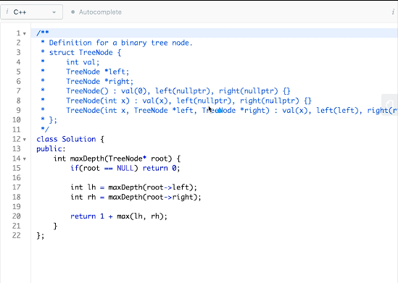

**TC & SC:-O(N)**

Check Balanced Binary Tree:-

Sol 1:-

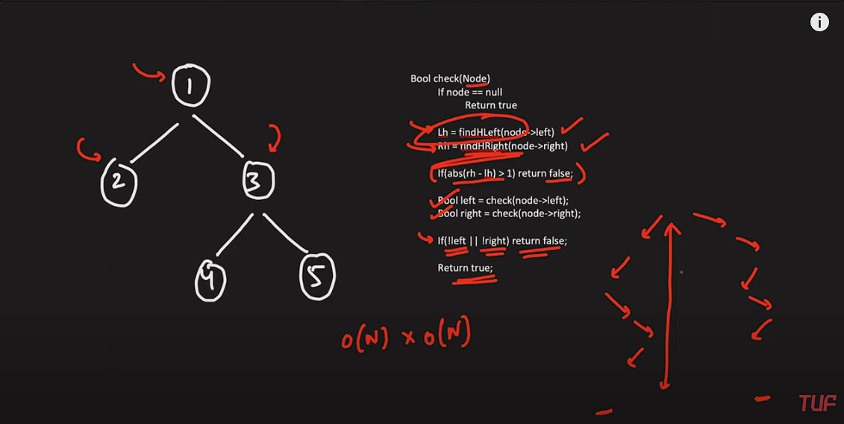

**Sol 2:-**

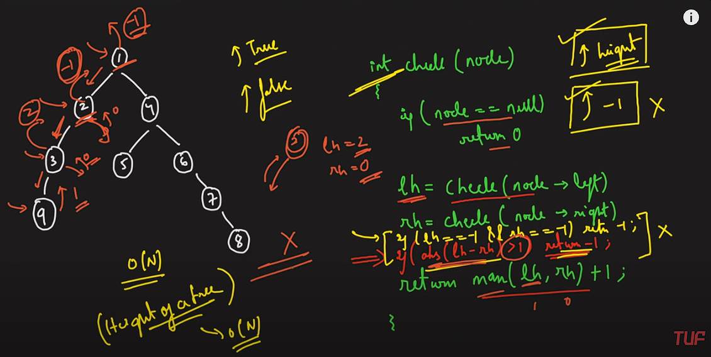

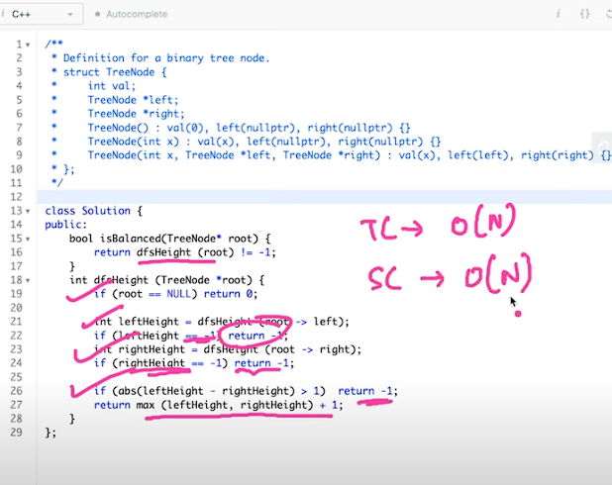

Diameter of a Binary Tree:-

Brute force:- (Traversing through all the nodes and counting max height from all the nodes)  
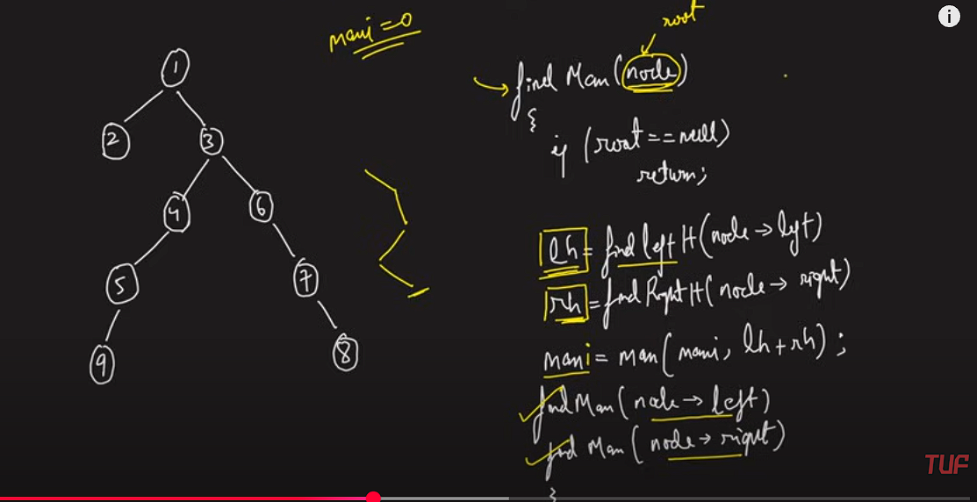

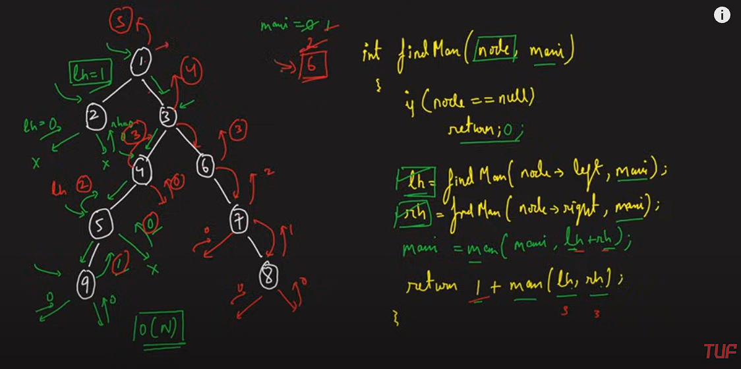

**Max Path Sum:-**

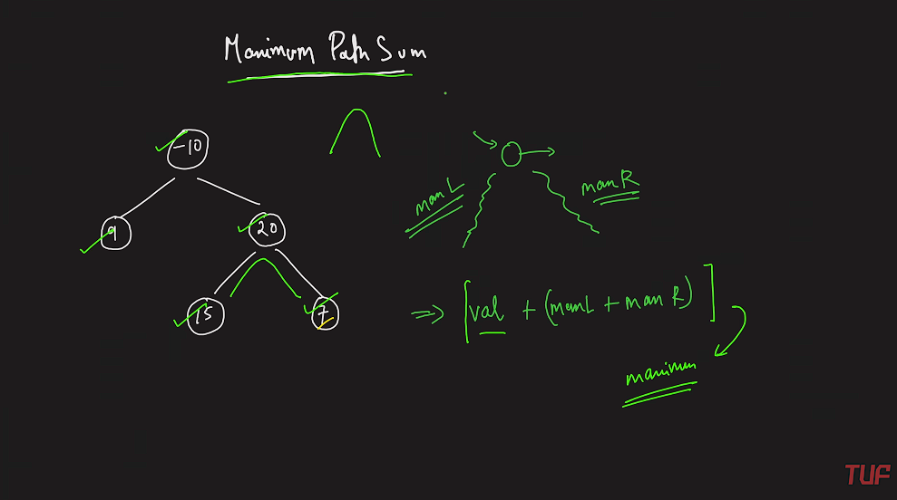

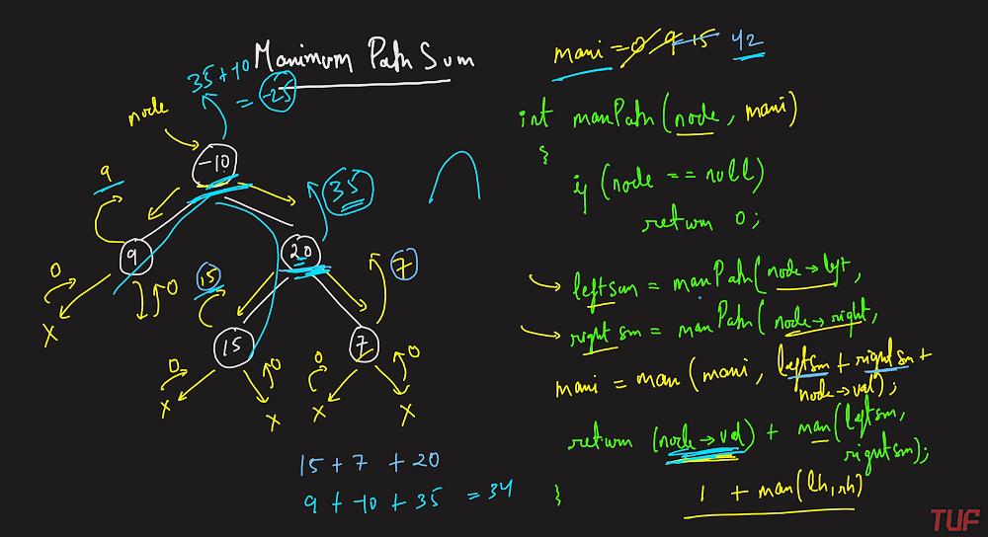

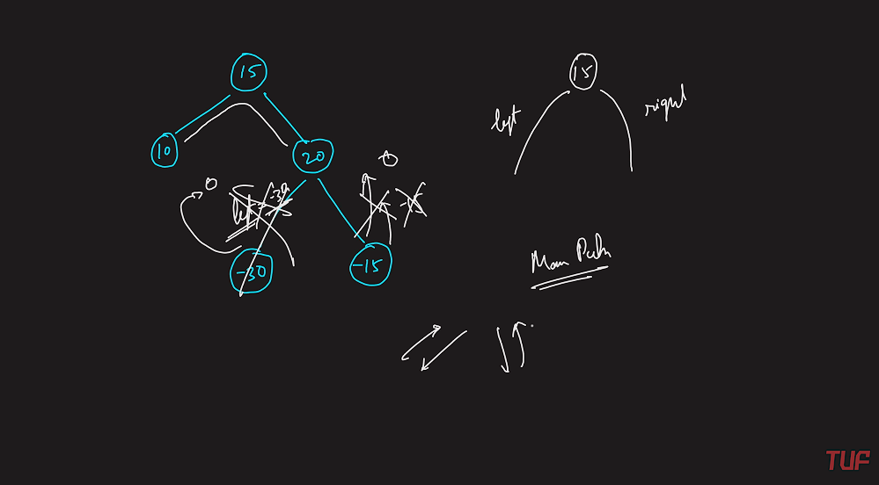

**Note:- Do not Consider the negative path instead return 0 whenever you get the negative path.**

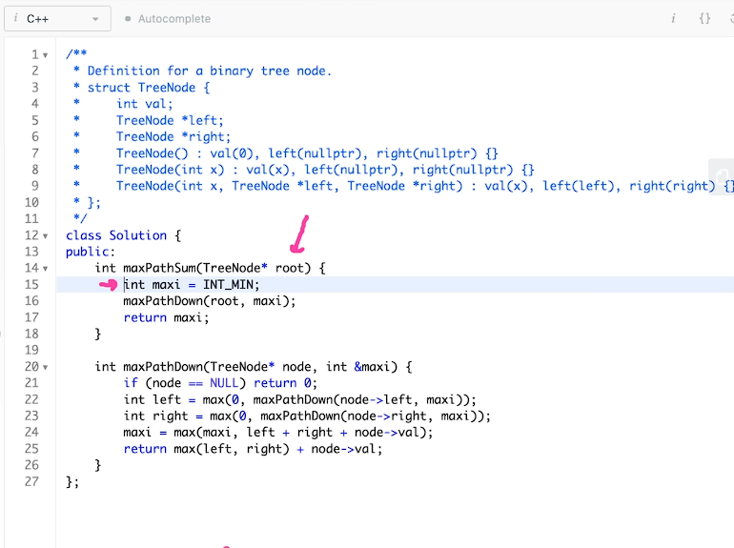

**Two Identical Trees:-**

